Biography – Joanne Nova

Joanne Nova makes a living out of explaining how the future of medicine and human health is going to change our lives. A professional speaker, Joanne gives keynotes or dinner presentations at conferences, and has spoken to hundreds of aged care experts, accountants, healthcare workers, teachers and financial planners. As a prize winning science graduate, Joanne has also done over 200 radio interviews, and hosted a children's television series called 'Y?'. Her first full time job was managing a Circus, the Shell Questacon Science Circus, where she travelled all over Australia taking science shows and exhibits to schools, town halls, and remote communities.

———————————————————————————————————————————-
Immortality as a dinner party dazzler

Recognise that dull look? You've got the most incredible news — but they want to know if there are nuts in the gateau-briande. You're talking about living to be 200 and they're responding as if it's a new tax plan. What are they on, you wonder? How could anyone not get excited?

How many of us with a passion, and a plan haven't been gob-smacked by how hard it can be for others to 'get it'. What follows are my summed trinkets of wisdom; the harsh lessons of public speaking that I've learned in order to keep my job, as someone who gets paid to speak. Mostly I'll stick to the handy things that work no matter whether I'm talking to one person, 300 people, or 300,000. Only occasionally will I resort to a crowd trick — to something that only applies to herds of humans as opposed to individuals.

1 It's A Question Of Credibility

1.2 Immortality Is That Kind Of Topic — Your Credibility Is On The Line

To share our excitement, we have to understand where the other person is coming from. Remember that for most people, most of the time, if they're listening to someone who speaks of 'immortality', they're listening to a freak. The overzealous speaker is either clinically insane or insufferably religious. Either way they don't want to excite the advocate too much, and they certainly don't want to offer encouragement. Hence the dull look.

Make sure that people know you're aware you tread a dangerous line, one where your credibility could fall off a cliff. This is where I resort to Rule One of speaking (see below); namely, you can get away with anything, as long as you acknowledge it. Right from the start I tackle the credibility question. Essentially it's saying something like, "I know you might think I'm crazy...". Because this statement is remarkably realistic it immediately marks you as someone with your feet on the ground.

Score one credibility point and move on, but stay focused on very real, very imaginable concepts. I always make sure people understand what I mean when I speak of immortality.

"It's not like Highlander, the movie where people can shoot people at point blank range and the victim walks away.' Immortality' means a cure for the degenerative diseases of aging – things like cancer, arthritis, heart disease and alzheimers. People will still die of accidents or suicide.

In short, we'll cure all forms of aging, but there is no cure for stupid."



This is a good point in a powerpoint presentation to put up a slide of me having a tea-party on a railway track. It's a very real, tangible message. So called 'immortals' will still die if they play with king-cobras or the Orient Express. Be real, be concrete, and talk in bats and balls rather than generalized concepts.

1.2 If You Don't Have Enough Credibility, Steal It
Unless you are a Berkley Professor, and even if you are, it can only help to quote experts. Don't be vague, name names, tell your listener why this person is so eminent in their field, and quote them exactly. If you're in front of a crowd it's OK to read it from a card*. It shows you're concerned about accuracy. Keep quotes to a bare sentence though. You only need to convince people that the expert agrees with your point of view. Reading anything longer than fifteen words will test any performer.

For example:
“The only practical limit to human lifespan is the limit of human technology”
Professor Michael Rose (Uni of California)

Here someone with a reputation they've worked hard to establish is willing to suggest that we could possibly control the length of our own lifespans. It's an example of a quite extraordinary transformation in the science community. A mere ten years ago very few notable scientists were willing to put their name to discussions about immortality.

*Don't do this at a dinner party. The 'I'm-a-freak' label will form an aura around your head.

1.3. What Makes A Point Convincing?

Use numbers. It's worth nothing to tell people that science has improved unbelievably, incredibly and phenomenally. They're all big words, and without hard facts, they're just hype. To convince people of just how much scientific work has accelerated in the last twenty years I analyzed the papers of the PubMed[1] library year by year, looking for words like telomerase.

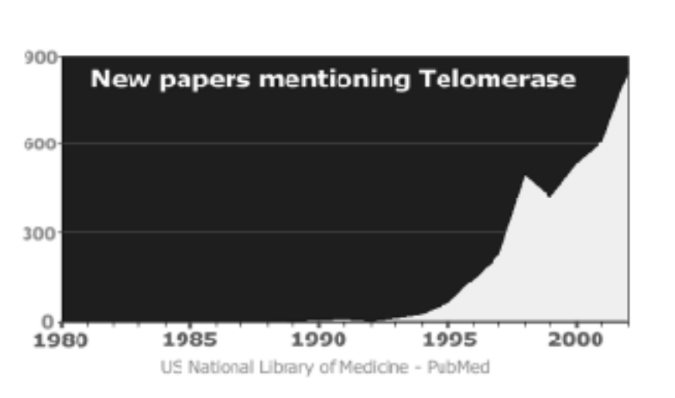

(As searched on the US PubMed data base in April 2002. The figures for 2002 are extrapolated from papers published up to then.)

You can see how the groundswell of research is shifting. Just ten years ago in 1993, there were 17 papers published that referred to 'telomerase' in the title or abstract. Last year, there were 879. Each year now we publish almost 16 times as many papers on telomerase as existed in all of human history up to the end of 1993.

2. How do you hold their interest?

2.1 Make Everything As Real As You Can
Don't just talk about people living to be ninety, with the body of a thirty-something. To capture someone's imagination, give them something they can visualize. Get into a few tin-tack details. Imagine this 90 year old's career, then consider their resumé. Your average ninety year old will have a killer CV. How is any twenty year old going to compete with them?

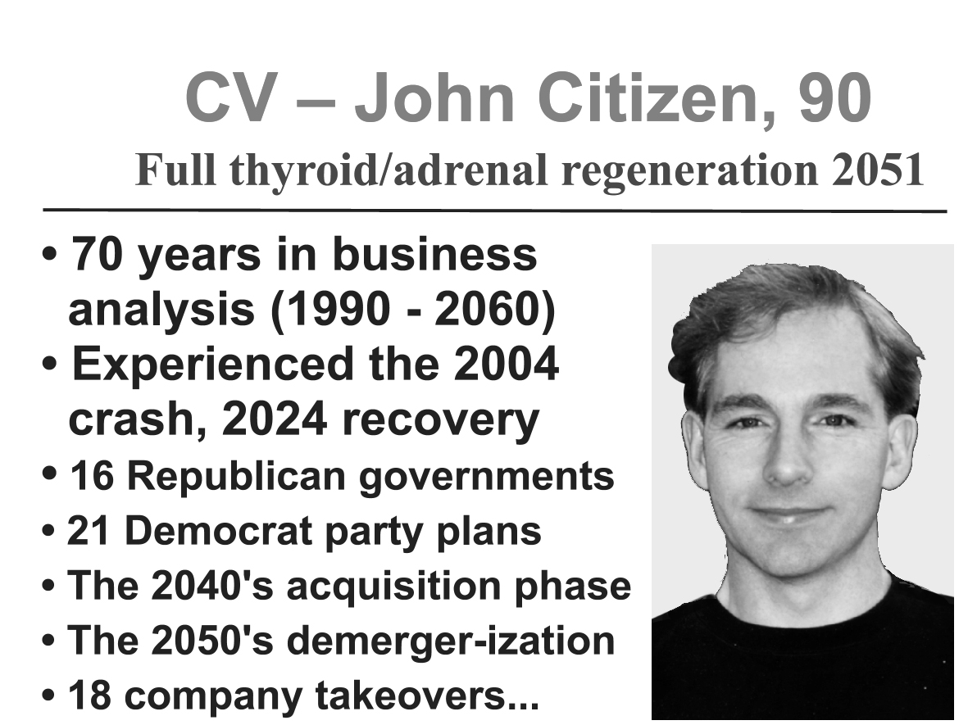

I created a slide (above) that I use to illustrate the point. There's the interesting contrast between a young photo and his age, and then you can hear the laughs when the line , "70 years in business analysis..." appears.

As a note for anyone using Powerpoint, the slide above really pushes the limit for the number of words on a single slide. I always start with just the face and title of this slide and add the lines one by one. I probably wouldn't get any laughs if I put it all up at once, because it's too much too deal with.

There's a nice contrast in that were not used to thinking of ninety year olds as competitive or being serious job applicants, but their day will come, and they could have an extraordinary advantage.

You have to concede though that the struggling twenty something's will always have their place in the job market. It's what they don't know that will make them irreplaceable. After all, they're not burdened by years of experience, they still think anything's possible.

The Stock-Standard Sceptic Chant: "Things Always Take Longer Than You Think"
This is almost a given if you're building a house or writing a report, but ponder what the average mum or dad would have thought if they'd known what was in store for them in 1900. At that stage no one had seen a plane fly. The only 'flying manmade objects were hot air balloons or kites. Imagine if you told them that in fifteen years their three year old boy would drive a horseless carriage that rode far miles above the ground? The first flight was yet to take off, but a mere fifteen years later there were hundreds of young men flying in dog-fights over Europe.

One thing that humans do really well is pick up new trends and run with them. It may take years for someone to invent something, but once it's done and people see the possibilities the uptake is astonishing. As long as there is a driving desire to use the new item, it will pursued relentlessly. When it comes to the Fountain-of-Youth, there is hardly a more desired objective. That's why the end-goal of longer human lifespans will overcome any obstacle. It won't be easy, and it won't be cheap, but once people sense that it is within our grasp we'll throw every dollar, every cent behind the search. Look at how much we already spend on even the faint promise of youthful health? Think cosmetics, botox and viagra.

Believe it or not, but quest for the Fountain -of-Youth is a sleeper industry. That's right, the not insubstantial industries of plastic surgery, health supplements, gyms, beauticians and snake oil supplies are only tapping the tip of the iceberg. Imagine how the money will flow, how votes will be directed once the average person realizes that there really will be a cure for cancer, the common cold, bad breath and baldness?

Acknowledge where people are coming from
One of the scariest things about being a speaker who talks about the coming medical revolution, is that it's the ultimate contest for the haves versus the have-nots. When an audience is full of people of varying ages, it's like there's giant divide within the audience. Not everyone is going to live long enough to benefit from the revolution. The younger you are — the better your chances. But what can you say to the audience? "On the one hand, you people, (the young ones) get life, the universe and eternal youth, but for the rest of you..., it's like 'bad luck buddy'."

It's rude, dismissive, and wierdly, it works really well. I admit to the audience that I have a dilemma. Then when I deliver the blunt undiplomatic synopsis, they laugh? All credit to the older folks who may miss out on the big prize. As long as I acknowledge their position they appear to cope with the bad news remarkably well.

Reassuring their fears
There are things worth worrying about in a long lived future, but some fears are unfounded. It's enlightening and reassuring to explore what won't change, rather than what will. Some things will always be a part of the human condition. No matter how long we live, or how much medicine tinkers, we'll always want to love, explore, communicate and share. For example predictions that women won't need men miss the point completely. One hundred million years of evolution mean that women will still fall in love, and they'll still be attracted to high status males with good senses of humor. These things are inextricable woven into our genes. Likewise, men will always find a young, healthy, fertile-looking female appealing — it's just that they'll have more choices. If someone told you tomorrow that you could have children without a partner, would it make you any less likely to seek out the man or woman of your dreams?

There's just no convincing some people
The bottom line is that in every crowd there will always be some incurable sceptics. There will also be someone who doesn't want to live forever, even if they could get their thirty-something body back. This of course is quite fair enough, indeed these people may be ahead of the crowd. It's possible that we will 'just get bored' of living. Some people may have 500 years in them, others just 50. One of my friends exclaimed "but will it make us happy?" It's a good but misdirected question. The aim of science isn't necessarily to make us happy, that's our job. Science is there to find the answers and give us choices.

Immortality won't necessarily make any of us happier, but it's hard to happy if you're dead.

How Do You Find The Funny Side?
The two ingredients of humor are, 1) a surprise, and 2) some truth.
I could surprise you by saying I'm going to the moon tomorrow, but there's no meaning, no context and no truth to it, so there's no joke either. Earlier, when I said "There's no cure for stupid..." the line tells us something that we all really knew, it's true. The surprise is in the idea that 'stupid' could be cured in the first place, or that it is a disease. We don't expect to see the word 'stupid' in a list of medical conditions.

Since you need to surprise people to get them to laugh there is only one way to arrange your message. There are four parts to a joke, and the order is critical.
- The set up: where you set people up to expect a particular thing,
- The punch-line: the line that matters,
- The punch-word: The word that gives the surprise away
- The pause: nothing comes after the punch-word

If I had rearranged the line "There's no cure for stupid..." and instead said "We'll cure all forms of degenerative diseases, but people who do stupid things will still die"... it just isn't funny. The word 'stupid ' gives the game away, and has to come last.

The fourth part, the pause, is critical. You can see why if you look at an EEG of a person who 'gets' a joke. The right brain waves must happen in a strong clean form and you can't afford any interruptions. If we analyze someone's brain just after they hear a joke we see two classic brain waves in quick succession. About a fifth of a second, 220 milliseconds after a joke, something called a P300 wave starts. The P300 is a sudden down-swing in neuronal activity. It’s a pause… clear the floors of all thoughts. This is where we wipe the blackboard and start again. Any unexpected thing will create a P300. This is where the 'surprise' in a joke kicks in.

A tenth of a second after the downswing, the opposite wave kicks in - the N400. It’s all systems go. We see major neuronal activity on the chart. In neurological circles the N400 is also known as the Double-Take wave. This is where the 'truth' in a joke gives your brain something to play with. The implications of the punch line send your brain into a frenzy of activity.

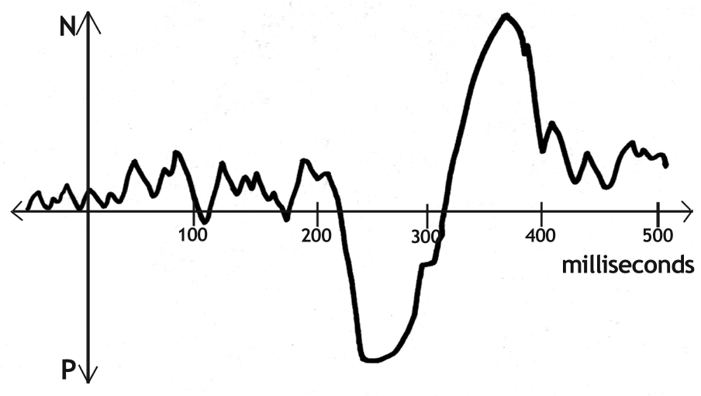
Here's what an EEG of a person 'getting a joke' might look like (above).

The whole wild swinging brainwave behaviour takes all of half a second. It's not long, but for that half a second, it's important that there are no interruptions. Hence, the famous pause is there for a reason.

The field of immortality is full of topics ripe for surprises; life, death, kids, careers, marriages and more.

Herd Behaviour: How To Use It To Help You
If you are in the position of speaking to a crowd, there are some very primeval forces at work. If you have any say about the way the event is organized you can give yourself a head-start. Firstly, it doesn't matter how many people are there, make sure there are only just enough chairs. Strangely, too few is better than too many. If you pack humans in they'll be more impressed with your speech and they'll laugh louder at your jokes. There's a killer psychological effect where we subconciously decide that if half the seats are empty, the speaker can't be much good. It's seems so unscientific, but an empty seat sucks energy from the room. Likewise, empty space also sucks. If the room is packed we all feel like 'this is the place to be'. The speaker must be good.

I've told one particular joke 500 times, and I can tell you that some days it's knock-down funny, and others it's flat. The difference is the room and the size of the crowd. The room that increases your impact is quiet. Noisy fans, traffic buzz, and microphones with insects trapped inside all suck the fun out of your punchlines. This makes sense when you think about the EEG brain waves required to create a laugh. The distractions interfere with a strong pattern. As for crowds — bigger is better. It's harder to get laughs out of a small crowd.

It's also harder to get laughs out of your overlords. It's true that we all laugh more at our bosses and other 'tribal elders'. People in positions of authority are funnier when they tell jokes, not because they tell better jokes, but because they're in charge.

Eerily and somewhat depressingly, most audiences laugh more at male speakers than at female ones. Again, it's probably the dominance factor. I hate to admit that men are more dominant even today, but laughter is a paleolithic thing — an involuntary reflex.

Paradoxically you only have to go to the gym to understand why women laugh more. There are twenty stacks of weight on some machines. After three years of training I'm still only using three weights. Someone is using those other 17 lead blocks. The difference in male:female arm strength is astonishing. What it boils down too, is that half of the population could have their way with me if my biceps were my only protection.

So my female forebears evolved other defenses and women today are left with an odd set of skills. Some of us can talk the socks off a terrorist. And most of us can laugh at his jokes. Laughter is our reward for him. It's kinda like saying, "You're clever, I like you, don't punch me."

Laughter is social lubrication. It's the great come-back of the lower ranking. It's a way of controlling the mood of a group from the bottom up.

So if you want to get more laughs rent a crowd, and make that a female flock if you can. But don't try your jokes out on the board of directors at AMP (unless you are the chairman).

———————————————————————————————————————————

WORD COUNT 2978

REFERENCES

[1] The National Library of Medicine: PubMed — http://ncbi.nlm.nih.gov/PubMed/ [accessed April 2002]

